**Novelty**

As part of implementation of “**Text classification of 20 News Group Dataset using Deep learning approach**”, the deep learning model called Convolution neural network has been applied. The corresponding model architecture is represented as follows.

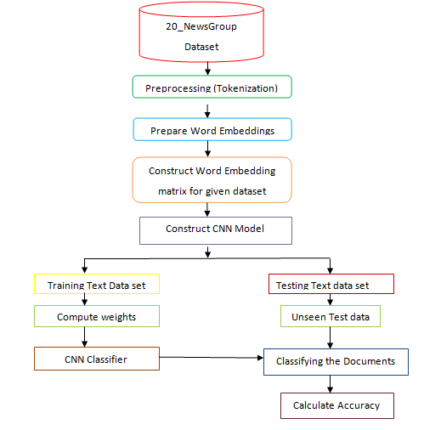

**Experimental Details**

This experiment is conducted over 20 news group dataset. This dataset is having 20k files. These files were splitted into training and testing files. The training part contains 16000 files and testing testing being performed over 4000 files.